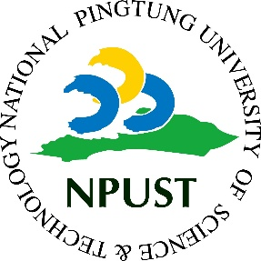

Memorandum of Understanding
Between

Department of …, National Pingtung University of Science and Technology, Taiwan

And
Name of Institution, Country

The Chairman of Department of , National Pingtung University of Science and Technology and the Chairman of Department of hereby affirm their intent to enhance cooperation in both education and academic research. The purpose is to promote academic exchange that will mutually benefit their respective institutions. The academic exchange considered may include, but is not limited to:
- The development of mutually beneficial academic and training programs;
- The exchange of students for purpose of studying; and faculty & staff for purposes of teaching, research and extension;
- Reciprocal assistance for visiting academic faculty, staff and students;
- Coordination of such activities as joint research and transfer of technology;
- Exchange of documentation and research materials in fields of mutual interests;
- Development of Dual Degree Program.

The details of the implementation of any particular exchange resulting from this agreement shall be negotiated between the two institutions as such specific case may arise, and is subject to availability of sufficient funds.
The purpose of this agreement is to promote academic exchange and may be subject to amendment, improvement or termination, at any time, upon the agreement of both Parties. This agreement is valid for five (5) years and shall become effective beginning the day after receiving the signatures of the authorized representatives of both Parties.

IN WITNESS, therefore, the parties have hereunto set their respective signatures on this date.

Signed for and on behalf of |  | Signed for and on behalf of
Prof. Dr. …  Chairman of Department of …  National Pingtung University of Science and Technology |  | (Name)  (Position)  (Institution)
Date: |  | Date:

