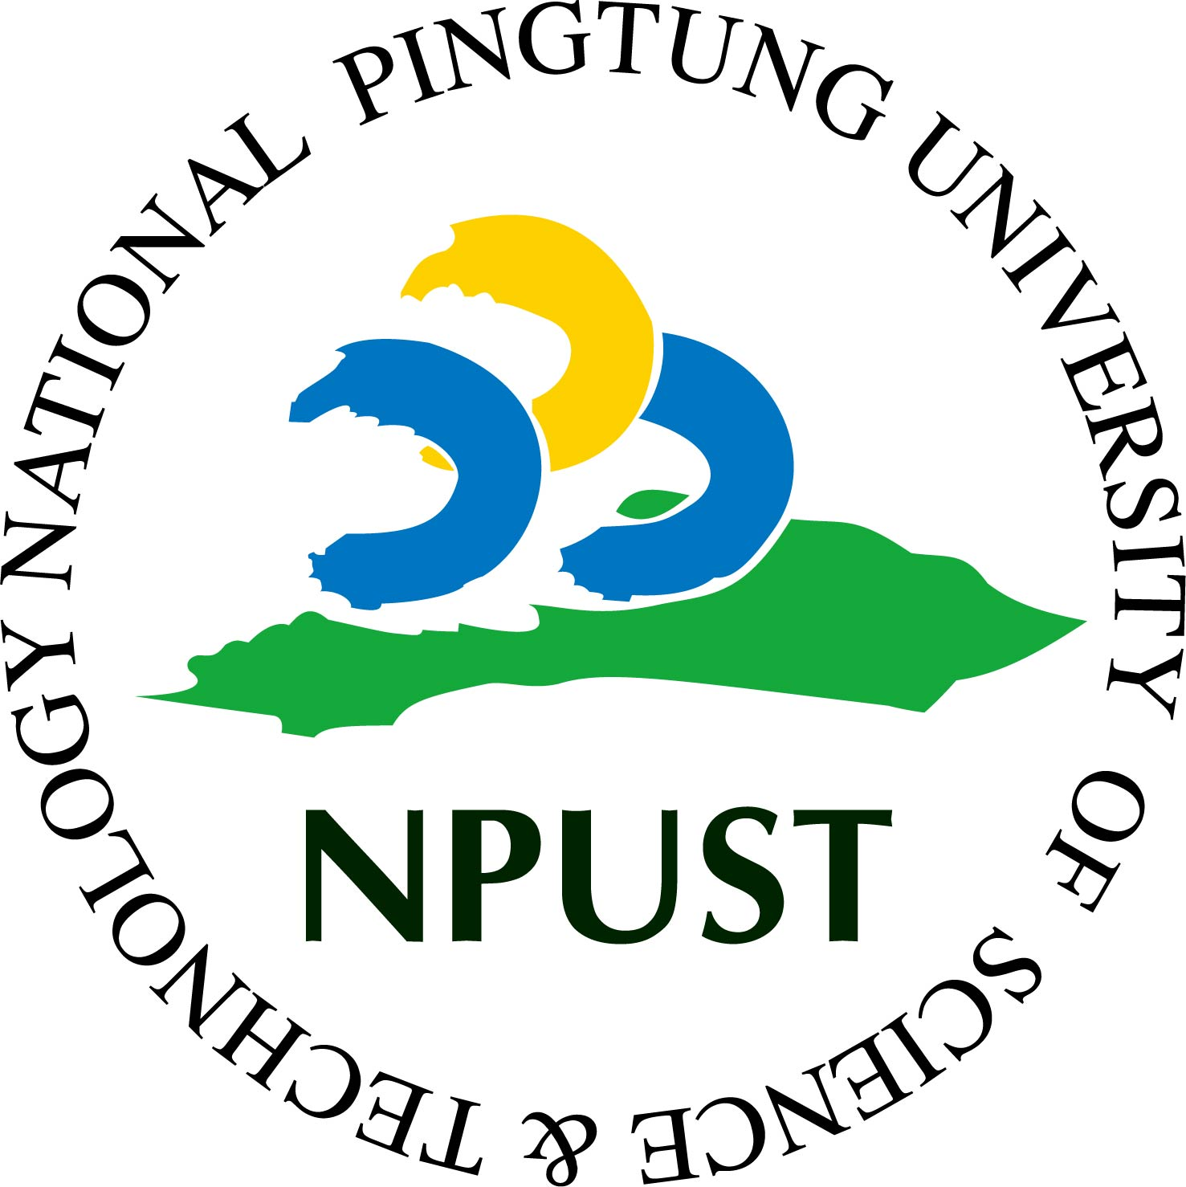
Memorandum of Agreement
Between
National Pingtung University of Science and Technology (NPUST)
And
Name of Institution

The (College/Department Name) of National Pingtung University of Science and Technology and the (College/Department Name) of _______________ intend to strengthen cooperation and enter into an alliance to conduct cooperative activities on the basis of mutual benefits in advances in research and education that are within the scope and expertise of both parties. In particular, areas related to [Research Area].

PURPOSE AND SCOPE OF COLLABORATION
The purpose of this MOA is to formally record the mutual interest of the Parties in opening discussions with each other with respect to furthering academic links and potential areas of collaboration between the two institutions. The potential areas of collaboration between the Parties may include, but are not limited to:
    - The development of mutually beneficial academic and training programs;
    - The exchange of students for the purpose of studying; and faculty & staff for purposes of teaching, research, and extension;
    - Reciprocal assistance for visiting academic faculty, staff and students;
    - Coordination of activities such as joint research and transfer of technology;
    - Exchange of documentation and research materials in fields of mutual interests;
    - Other forms of cooperation which the two institutions may jointly arrange.

DEFINITVE AGREEMENT(S)
- The Parties understand and acknowledge that any initiatives which may arise from the discussions pursuant to this MOA will be subject to: (a) the successful negotiation and execution of definitive agreement(s) between the Parties (the “Definitive Agreement(s)”);
- The two institutions shall decide through consultation, the specific areas and details of co-operation within the framework of this agreement. The financial arrangements involved in the implementation of this agreement shall be settled through consultation between the two institutions in respect of each program of co-operation
REPRESENTATIVES AND NOTICE
Each Party will identify individuals as their respective liaison(s) for the purposes of holding discussions in accordance with this MOA. Whenever this MOA requires notice to be sent to the other Party, notice will be sent to the identified liaison(s) identified below:

TERM AND TERMINATION
- Subject to early termination as provided for in this MOA, this MOA commences on the Effective Date for a term of five (5) years (the “Term”).
- Either Party may terminate this MOA at any time for any reason or no reason by providing the other Party at least sixty (60) days prior written notice addressed and delivered to the liaison(s) identified in section 3 above.
- The Parties may renew or revise this MOA only upon mutual agreement of both Parties.se or Taiwanese courts.

IN WITNESS, therefore, the parties have hereunto set their respective signatures on this date.

Signed for and on behalf of  National Pingtung University of Science and Technology |  | Signed for and on behalf of  (University Name)
_________________________________ |  | _________________________________
(Name)  (Title) |  | (Name)  (Title)
Date: ____________________________ |  | Date: ____________________________

